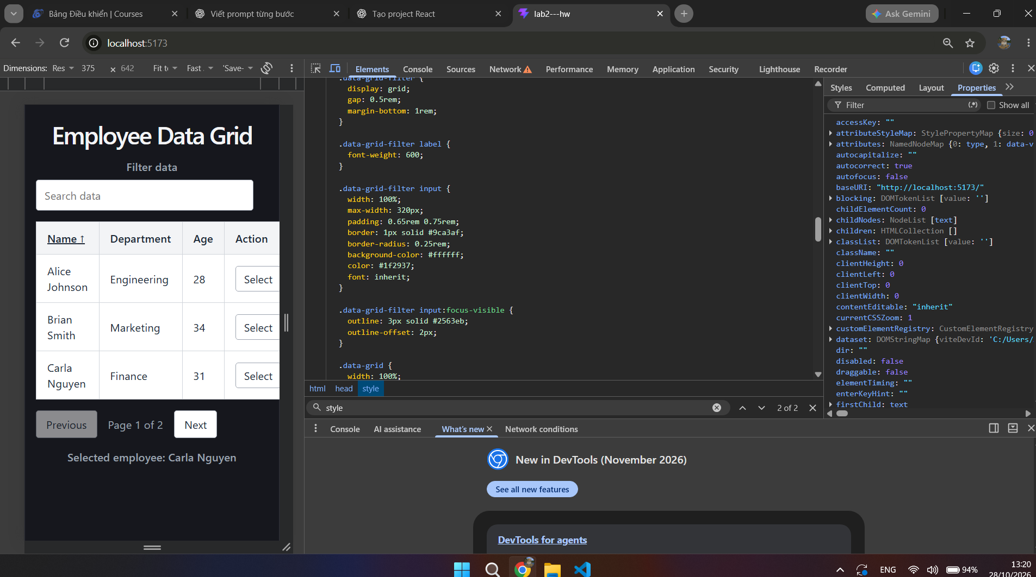
Figure 1. Accessibility-focused DataGrid interface with visible focus styling inspected in Chrome DevTools.
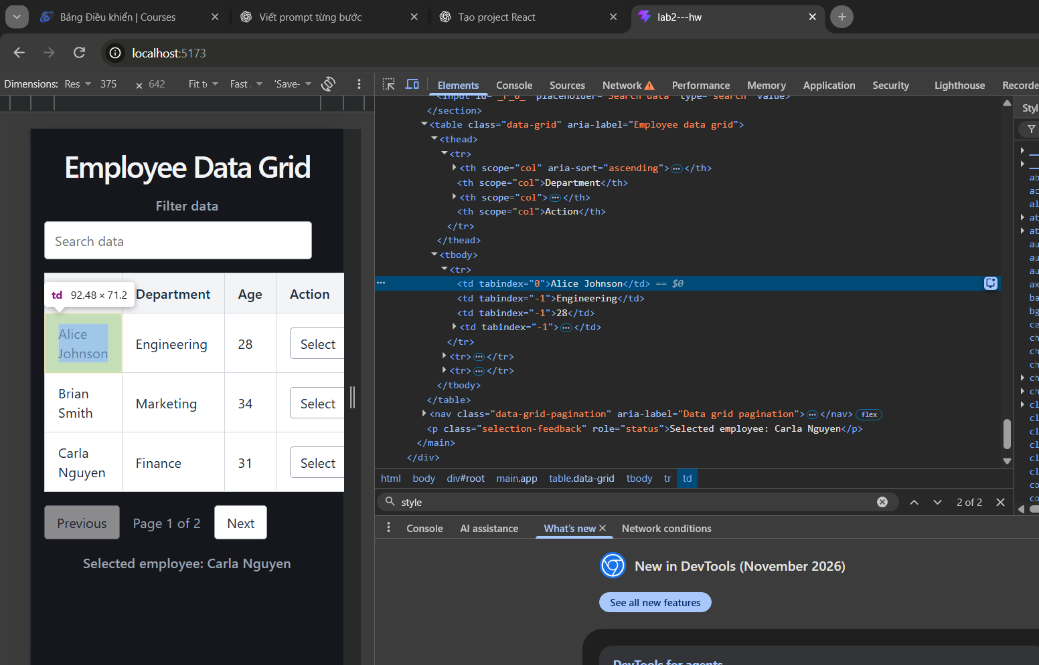
Figure 2. Semantic DataGrid structure, ARIA attributes, and roving tabindex behavior verified in Chrome DevTools.
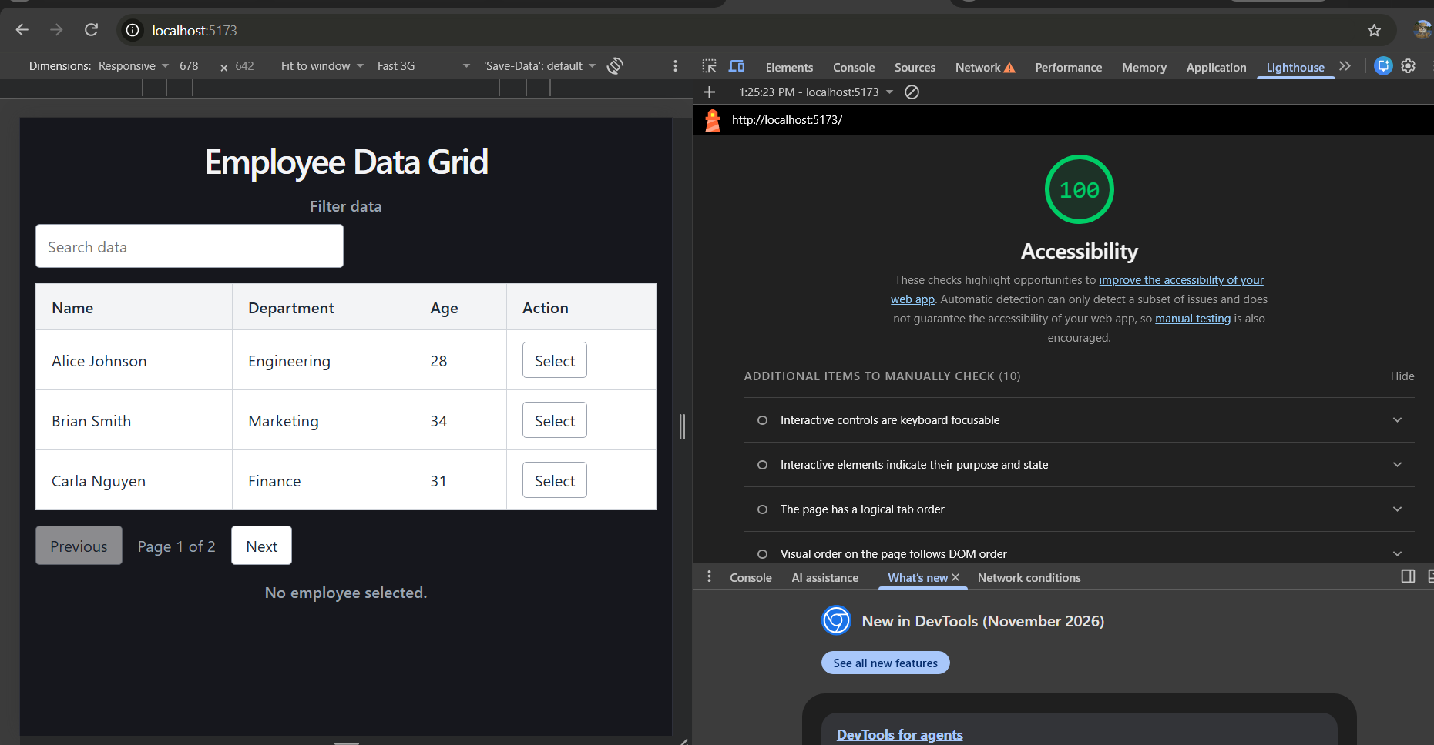
Figure 3. Lighthouse accessibility audit achieving a score of 100/100.
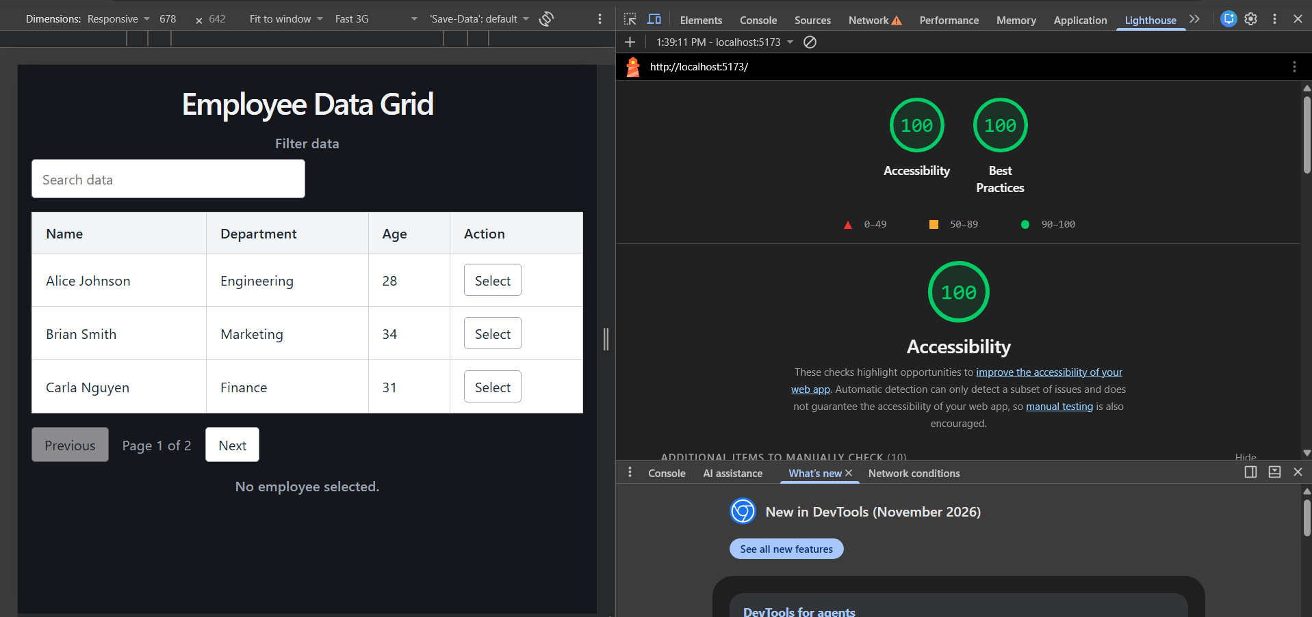
Figure 4. Final Lighthouse audit achieving 100/100 for Accessibility and Best Practices.
Homework 1
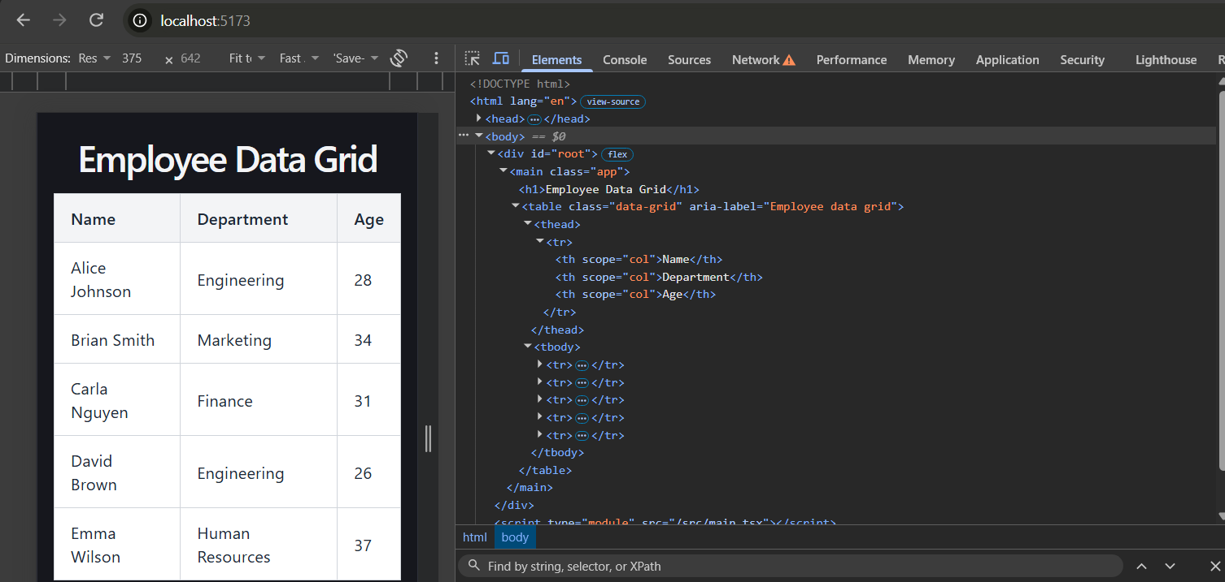
Figure 5. Semantic HTML table structure verified in Chrome DevTools using table, thead, tbody, th, and td elements.
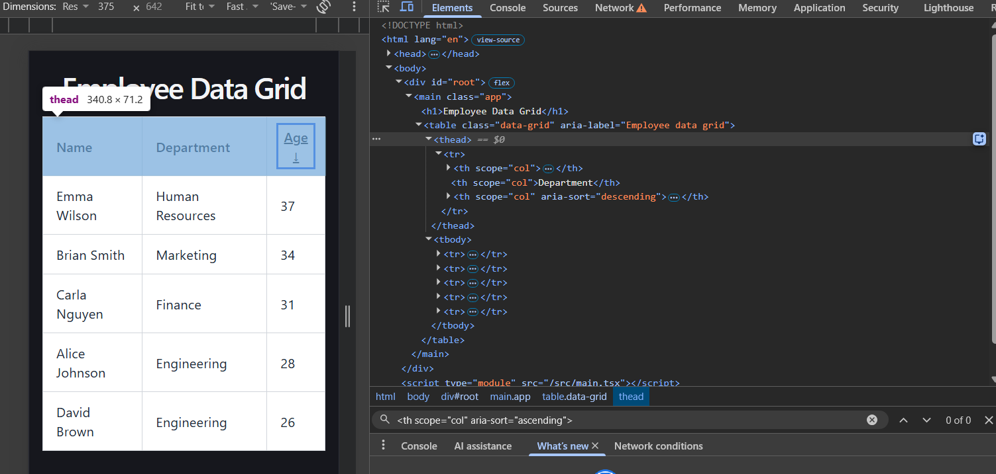
Figure 6. Descending Age column sorting with the accessible aria-sort state verified in Chrome DevTools.
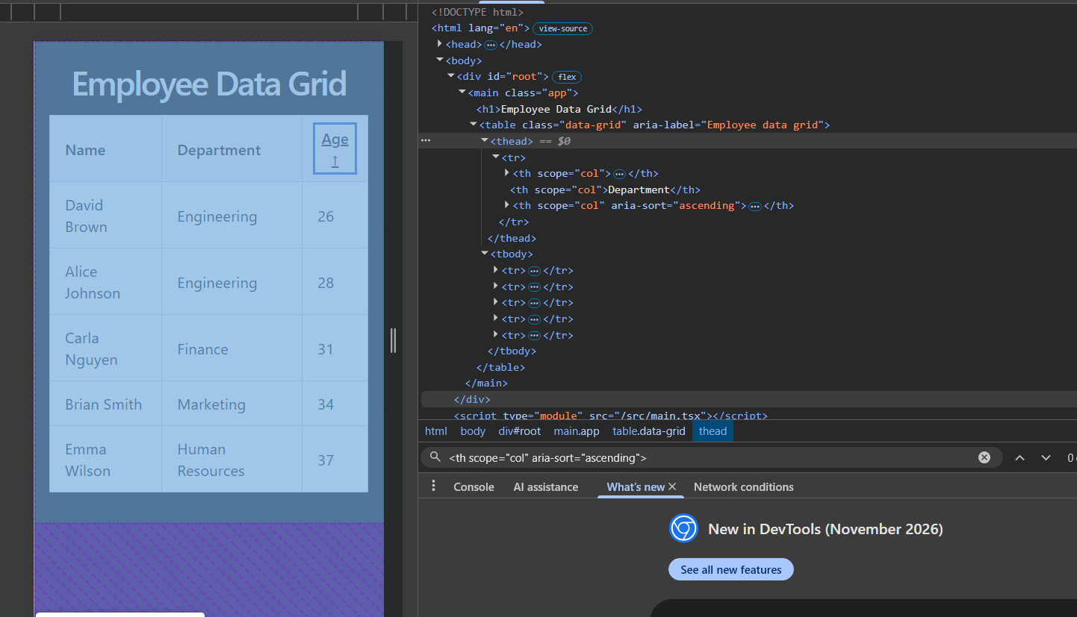
Figure 7. Ascending Age column sorting with aria-sort="ascending" verified in Chrome DevTools.
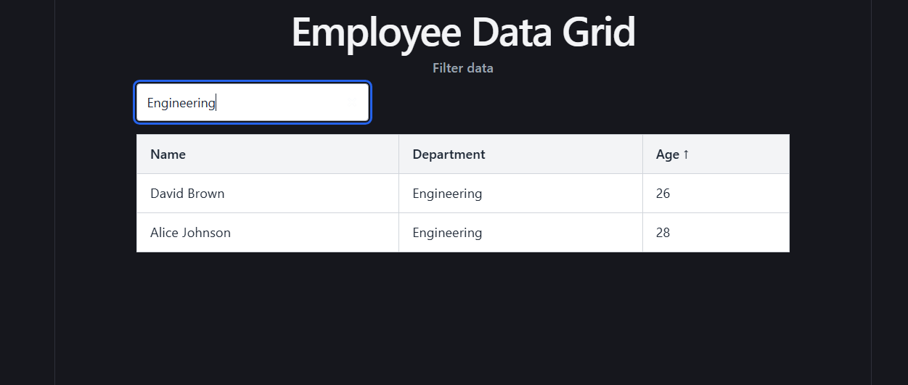
Figure 8. Employee filtering by Engineering combined with ascending Age sorting.
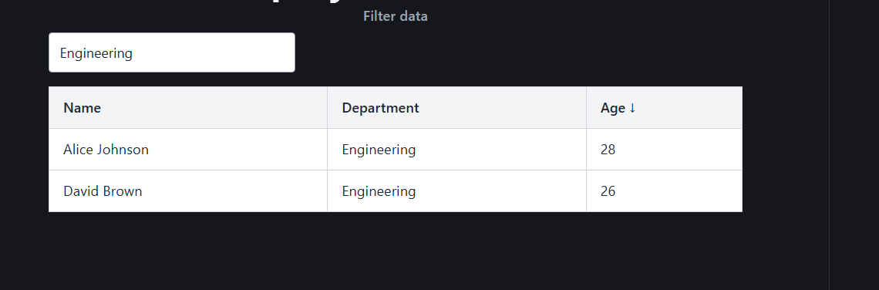
Figure 9. Employee filtering by Engineering combined with descending Age sorting.
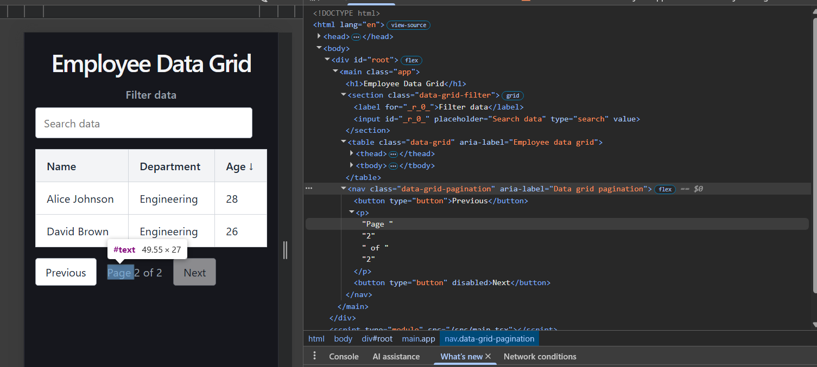
Figure 10. DataGrid pagination on Page 2 of 2 with the Next button correctly disabled.
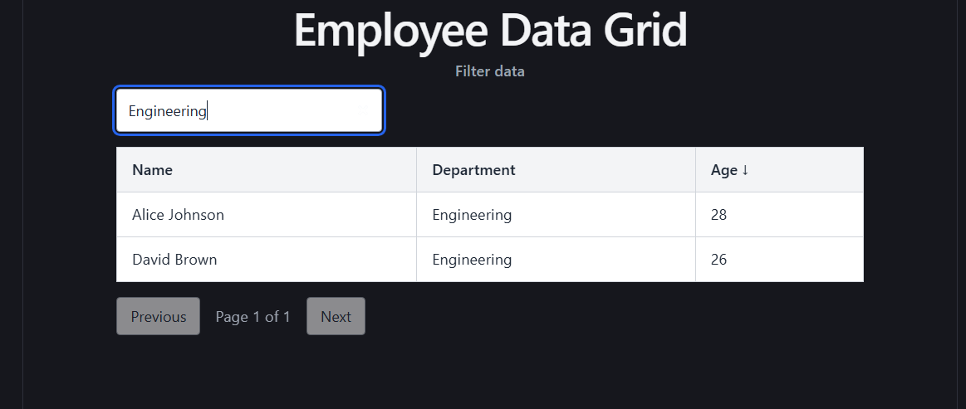
Figure 11. Pagination automatically adjusted to Page 1 of 1 after filtering the employee data.
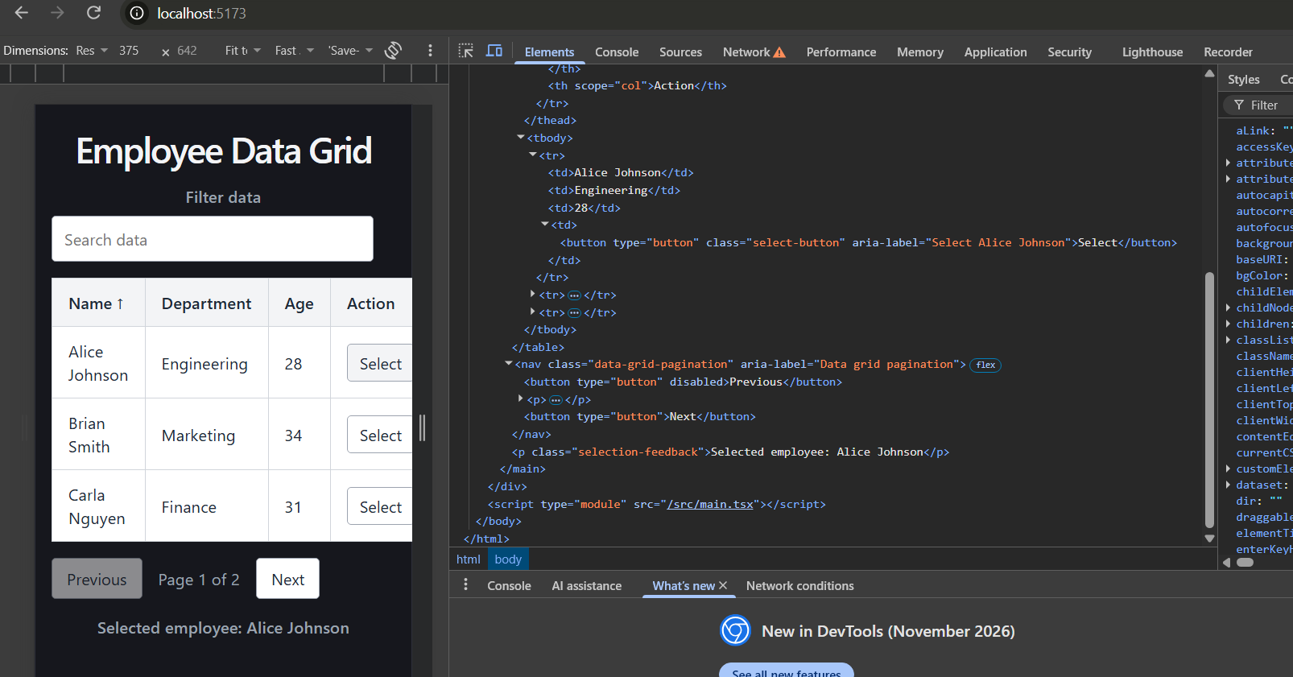
Figure 12. Row selection of Alice Johnson with accessible selection controls and selection feedback.
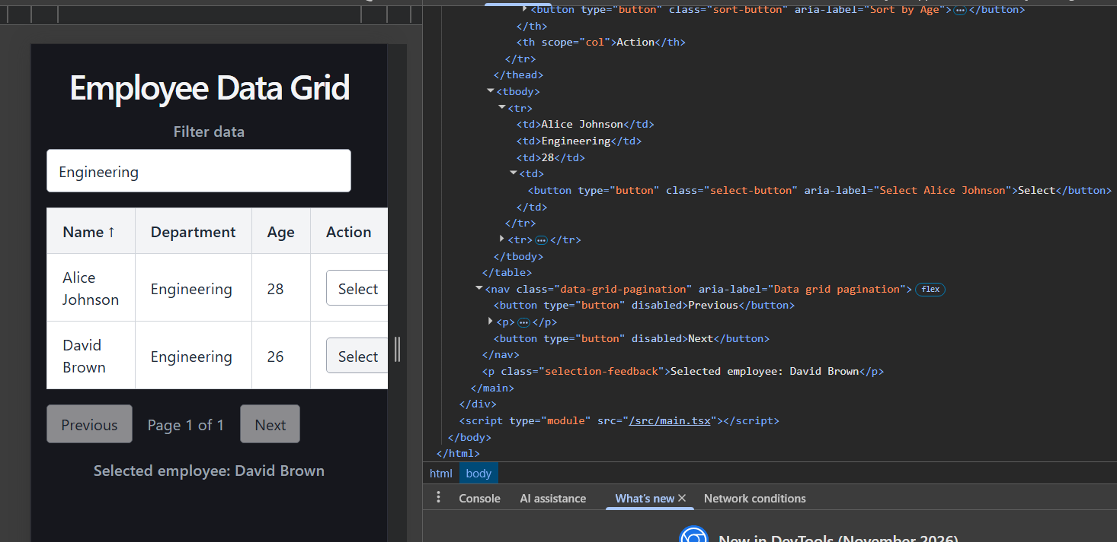
Figure 13. Correct row selection of David Brown after applying the Engineering filter.
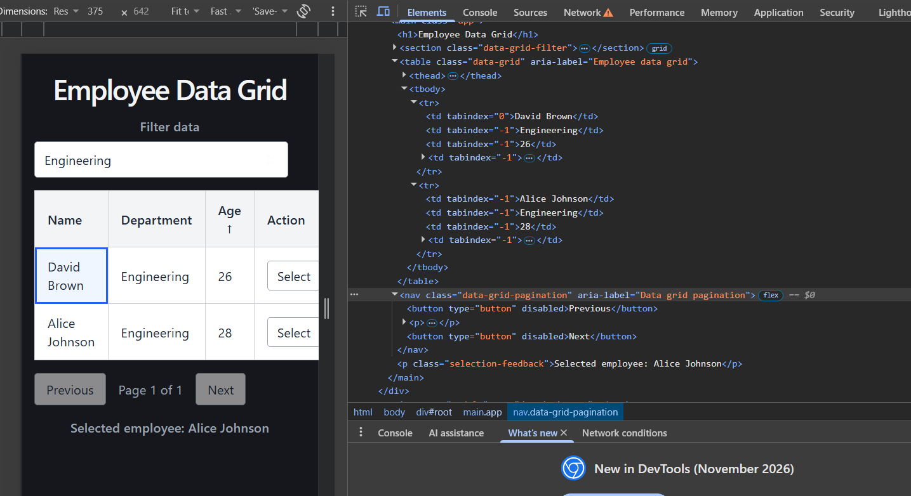
Figure 14. Visible keyboard focus on a DataGrid cell using roving tabindex navigation.
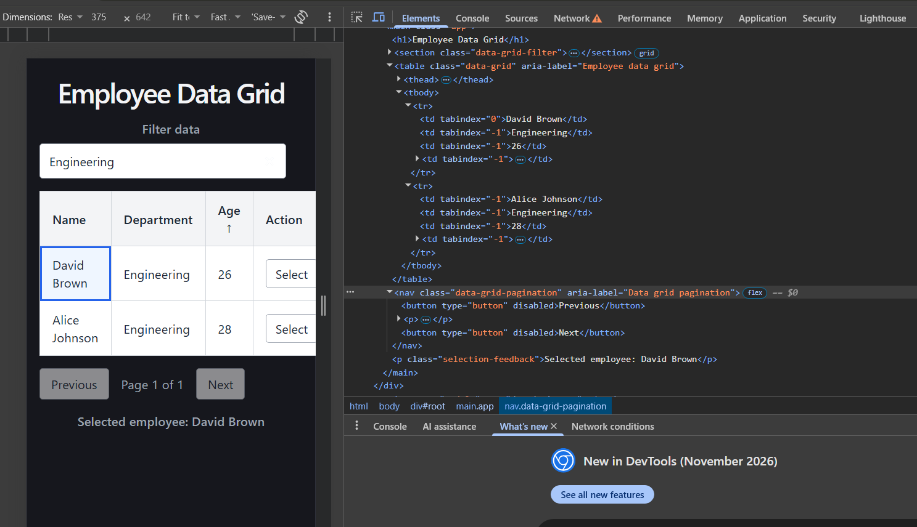
Figure 15. Keyboard-based row selection of David Brown with visible focus and updated selection feedback.

